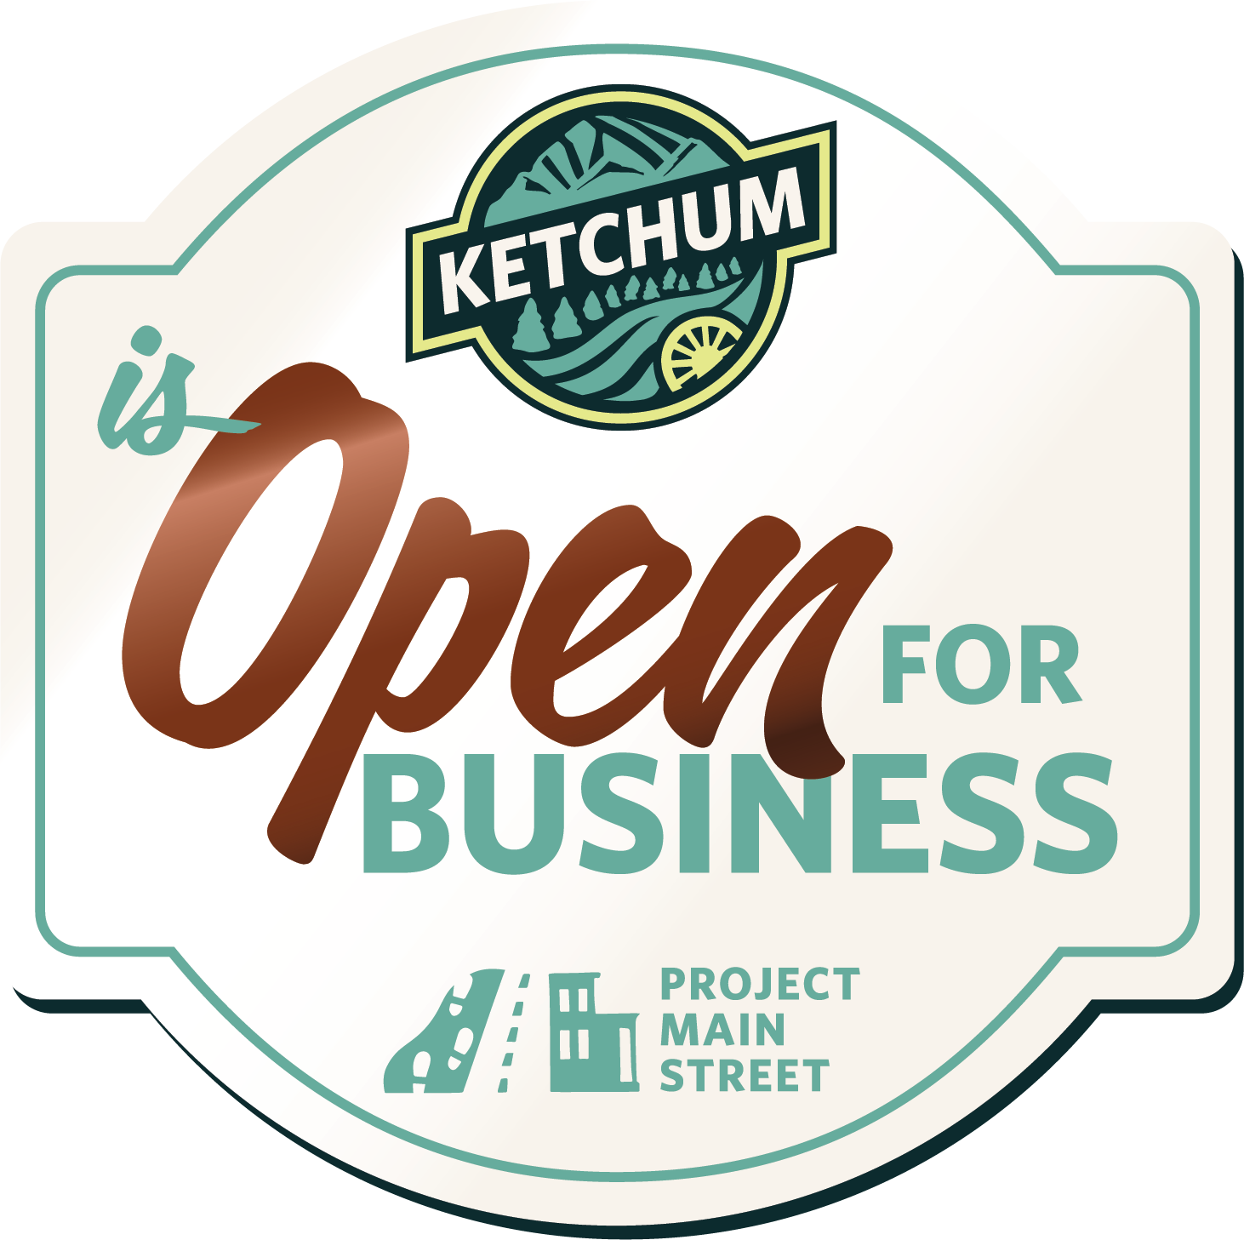
Main Street construction from River to 6th Street will take place in Ketchum this April through the end of October. It is a major undertaking and an exciting opportunity! Improvements will include a new roadway with better traffic flow and improved pedestrian amenities.
Access to all your favorite shops, restaurants, events, and services is open throughout the project—be sure to support your local businesses. And stick around for Main Street’s new look this fall!

STAY INFORMED
Work will be completed in phases. Vehicle access may change based on the current construction location. Pedestrian access will always be open. Visit projectketchum.org/main-street (or scan the code) for updates or to receive news by email.
Text JOIN MAIN to 208-202-5642 to receive text alerts.
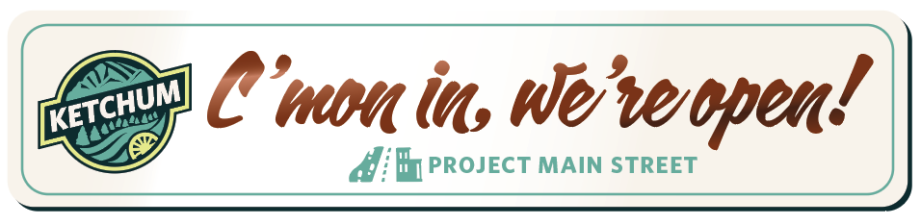
Access is open to all Main Street businesses throughout construction, just look for the ADA-accessible pedestrian entrances. Thank you for supporting our local businesses!
